Day 3 Lab Assignments
Do the following CSS style for the given HTML page (run the page and see the result after each point):
- Make External CSS file for that:
  - Make the font type "Lucida Calligraphy" for any p or div or span tag (use one CSS rule).
  - <h1> tag which is child from div tag to be in the center of the page.
- Make inline style for the div with "header" id, that make its width=100%, and its background color red.
- Make inline style for the span which its id is "linksbar" , that make its width=25%, its background color gray, and make it starts from the left of the page (float property).
- Make inline style for the span which its id is "content", that make its width=75%, its back color pink, and make it comes to the left side after the previous span (float property).
- Make internal style that:
  - Make a class name "none-bullet-list" that can be applied on <ul> tags, and makes list style type of the <ul> without bullets (none), and apply this class on the <ul> tag that contains the links (apply it to the <ul> tag in html directly, the selector will be class name only).
  - Make color red, and background color pink for the links that're direct child for <li> tag, which inside span with id= "linksbar", and make it appear without underline (text-decoration property).
  - Make color pink, and background color red for the links that're direct child for <li> tag, which ( inside span with id= "linksbar", when mouse is over it.
  - Make the font weight bold, and font size 12px, for the paragraph that comes directly after (sibling) <h2> tag which is direct child for <span> with id="content".
  - Make a dashed border, with size 2, and color rgb(20,70,60), for the div with id " loginform".
  - Make style that makes the background color yellow of the any <input> of type "text", and another style that makes its background color white when it's focused.
  - Make a class named "tabled-bordered" that can be applied on any tag, and make it displayed as table cells (use display property), its padding 5, and make a border for it. Apply the class to the 3 <p> tags that are in the "titles" div (apply them on the p tags that are in "titles" div in html file, the selector will be class name only).
    - Try to change the <p> tags inside the div with id "titles" to spans, is there any difference?
  - Use ::after pseudo element, to add this text “Read this” with color yellow” after the paragraph that is nested from span.
- Make 2 internal styles as the following (With the same order):
  - Color yellow for the <p> with id "aboutus" that's direct child from span with id "content".
  - Color red for the <p> with id "aboutus".
Which style will be applied to the paragraph? And why?

- Use !important with the second style of the previous 2 styles. What's the change that happened and why?
The page should be like that after you apply the previous styles:
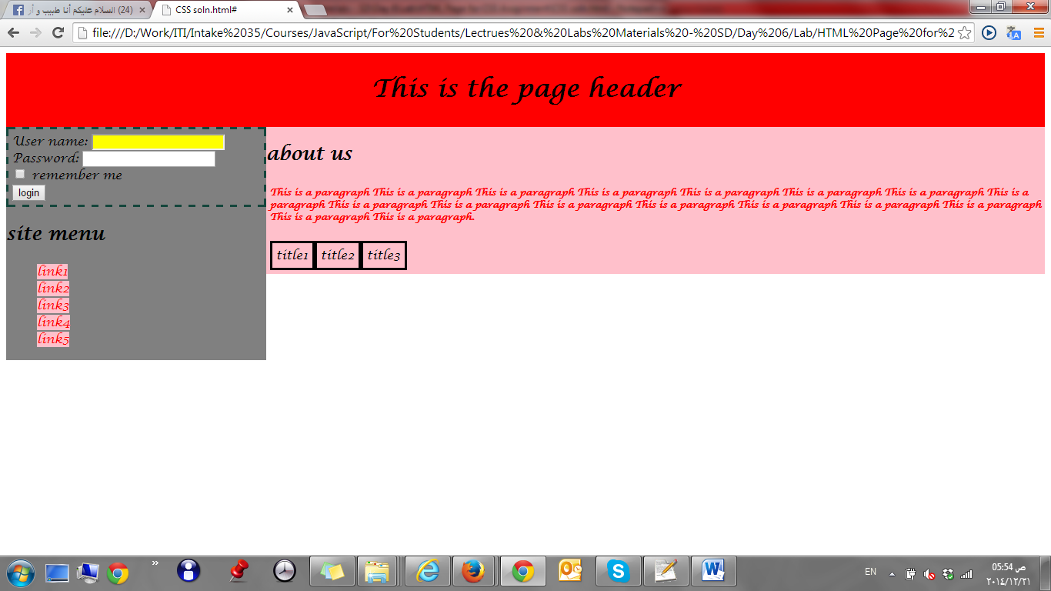

- Make a Navbar like the following:
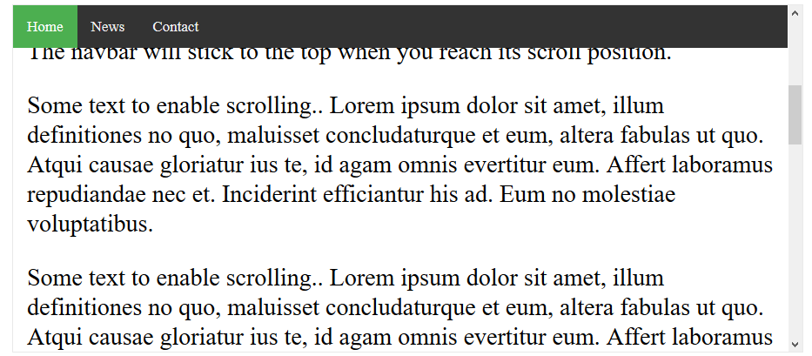
  - Make the navbar items as list (ul), and inside each list item (li), add a link for each menu item.
  - Use list style type: none for the list items.
  - Use display: inline-block for the list items. (Why?).
    - What’s the difference between the following display values: inline, block, inline-block?
You can refer to the following links:
https://www.w3schools.com/css/css_inline-block.asp
https://www.w3schools.com/cssref/pr_class_display.asp
https://stackoverflow.com/questions/9189810/css-display-inline-vs-inline-block
http://dustwell.com/div-span-inline-block.html
https://alligator.io/css/display-inline-vs-inline-block/
http://learnlayout.com/inline-block.html
  - Handle that when mouse over an item its background color to be changed.
- Made the previous navbar to be fixed position, and add any content below it (paragraph for example)
  - You’ll need to push down the position all elements below the fixed elements, you may use padding property.
  - Change the navbar to be position: sticky. (What’s the difference?).
- On home page in Day.2 assignments, redo the page layout using CSS instead of table-based layout. (you can follow the following guidelines: (https://www.w3schools.com/css/css_website_layout.asp)
- On the registration form in Day.2 assignments:
  - Show * besides the required inputs (if you will use ::after pseudo element, you need to put each input inside a div or span, and apply ::after to the container div or span of the input, as the it will work with the elements that have content only)
  - Make the inputs that are not valid has black border, and show span below it “Not valid” (use :invalid pseudo class).
  - Make the inputs border white, and make the span below it not visible when the inputs become valid (use :valid pseudo class).
- Make rounded link button as the following (Use <a> tag): 
Bonus (Have fun with CSS J ):
- Calculate the specifity, for the 2 styles in assignment No. 6, in the part 1 assignments.
- Search how to make an icon to your website that appears next to website title in the browser.
- Redesign your home page to be similar (just use it as a template, it shouldn’t be exactly like it) to the following template (Don’t use table-layout)

  - Use background image in the header like the following: https://www.w3schools.com/howto/tryhow_css_halfpage_demo.htm
  - Change the background image in the header, to be background video like this:
https://www.w3schools.com/howto/howto_css_fullscreen_video.asp
https://medium.com/@aswin_s/fullscreen-video-backgrounds-e8376ef93c72
  - Make the previous page as a single page, and handle transition when moving between different sections, and add a simple navbar on the top of page (When click each item it should redirects to the related section) like the following:
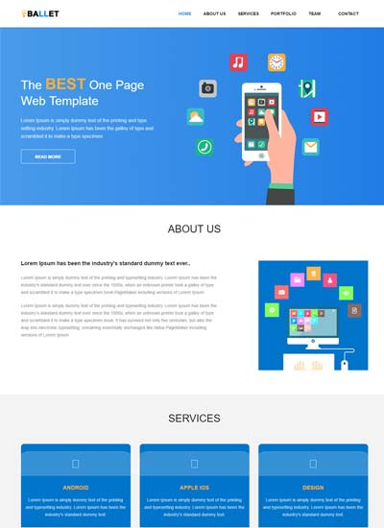
- Style the registration page on Day.2 Assignments using CSS, to be like the following style: http://demos.w3lessons.info/material-design-form/ .html
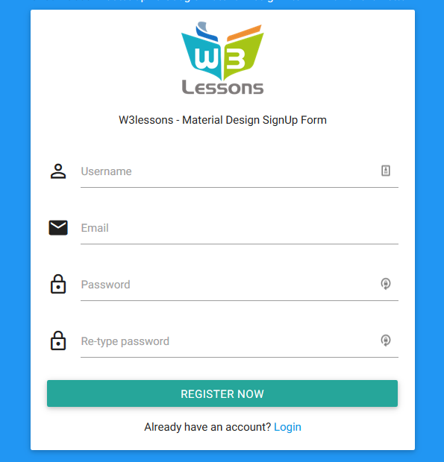
  - Make style the registration button to be like the prev. image full width and borderless. (Like the following button style).
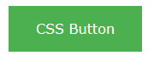

- Follow the following demos to see how to center elements horizontally and vertically:
https://www.w3schools.com/css/css_align.asp
https://css-tricks.com/centering-css-complete-guide

- Use z-index and position properties, to make a text above an image like the following:

  - Use opacity property to make the text transparent like the following:
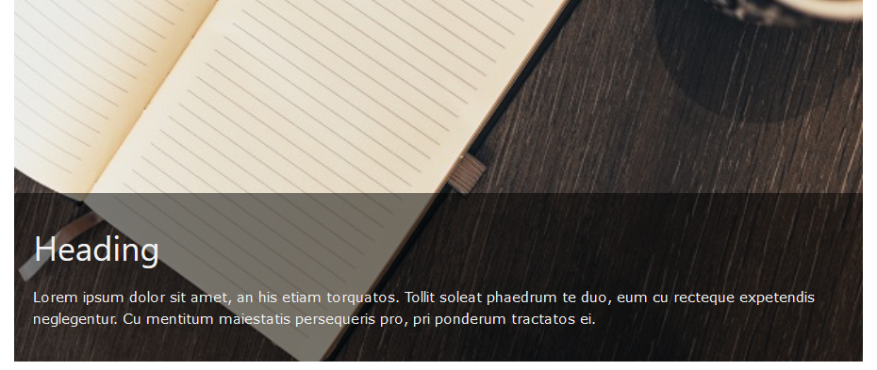
- Create contact us form like the following:
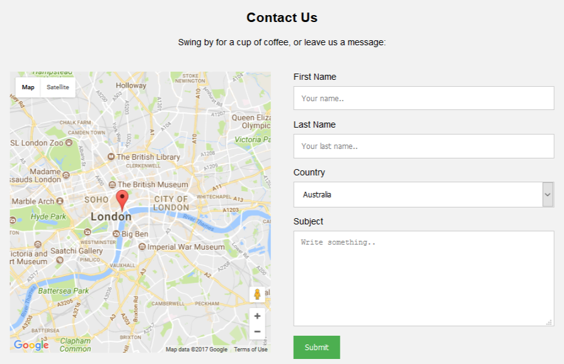

- Design product card like this one:
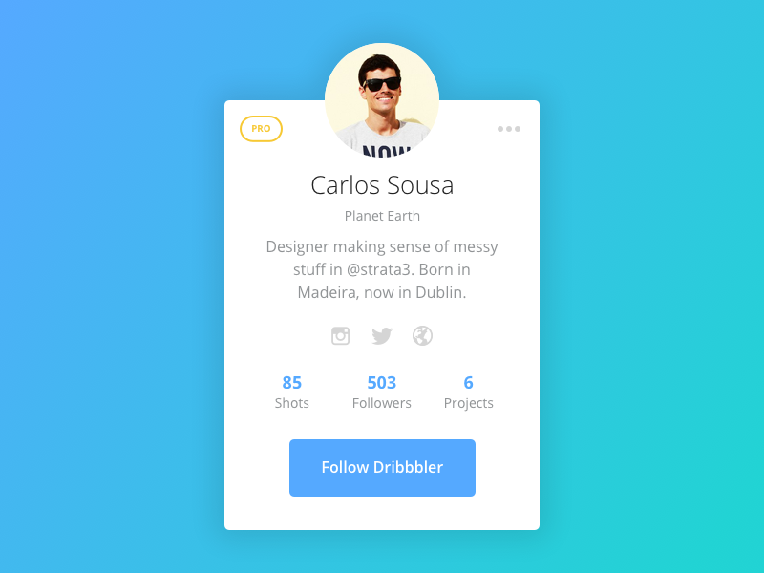
- Create custom CSS checkbox and radio buttons like the following: https://www.w3schools.com/howto/howto_css_custom_checkbox.asp
- Make full page background image with parallax scrolling effect (Scrolling background image) in a page, like the following website: https://www.soundsnap.com (Make a home page like this website with all CSS effects on it)
(You can follow the following demo to know about the parallax scrolling effect: https://www.w3schools.com/howto/tryit.asp?filename=tryhow_css_parallax).
- Use CSS to make the following info bars (Without using bootstrap)
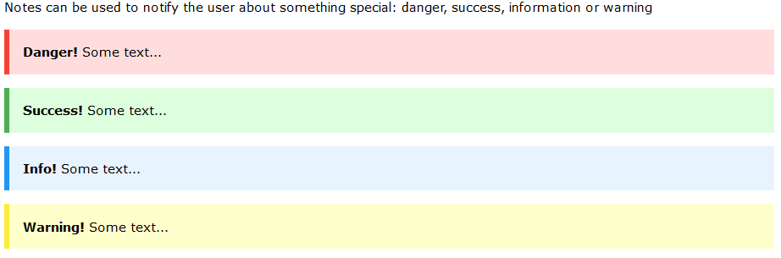

- Use CSS to create HTML page that has dropdown menu like:
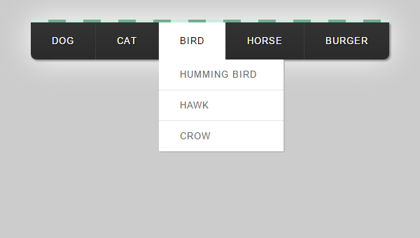
- Use float property to make photo gallery like the following:
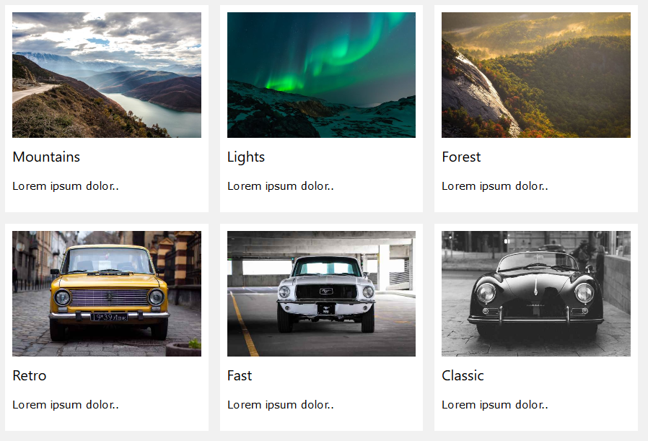

- Create chat message like the following:

- Review the following CSS Demos and code snippets and then redo them by yourself:
  - http://cssdemos.tupence.co.uk/stepbystep/stepbystep-image-caption.htm
  - https://www.w3schools.com/howto/howto_css_full_page.asp
  - https://www.w3schools.com/howto/howto_css_fullscreen_video.asp
  - https://www.w3schools.com/css/css_tooltip.asp
  - https://www.w3schools.com/howto/howto_css_tooltip.asp
  - https://www.w3schools.com/css/css_navbar.asp
  - https://www.w3schools.com/css/css_dropdowns.asp
  - https://www.w3schools.com/css/css3_pagination.asp
  - https://www.w3schools.com/css/css_image_gallery.asp
  - https://www.w3schools.com/css/css3_buttons.asp
  - https://www.w3schools.com/howto/howto_css_timeline.asp
  - https://www.w3schools.com/howto/howto_css_overlay.asp
  - https://www.w3schools.com/howto/howto_js_sticky_header.asp
  - https://www.w3schools.com/howto/howto_css_fixed_sidebar.asp
  - https://www.w3schools.com/howto/howto_css_image_sticky.asp
  - https://www.w3schools.com/howto/howto_css_mega_menu.asp
  - https://www.w3schools.com/howto/howto_css_full_page.asp
  - https://www.w3schools.com/howto/howto_css_hero_image.asp
  - https://www.w3schools.com/howto/howto_css_parallax.asp
  - https://www.w3schools.com/howto/howto_css_profile_card.asp
  - https://www.w3schools.com/howto/howto_css_product_card.asp
  - https://www.w3schools.com/howto/howto_css_contact_chips.asp

<Script>document.write(“Thank YOU”) </Script>

